**Add custom CSS to your site**

In this example, we are going to add some custom CSS files that will allow us to add shadow effects to buttons on our website. You can use your own custom CSS file or use the sample provided.

1. To create a sample, in your favorite CSS editor, create the **button_shadow.css** custom theme file and save.

cssCopy

.button1 {

box-shadow: 0 9px 18px 0 #333333, 0 8px 24px 0 #333333;

}

1. Go to [Power Pages](https://make.powerpages.microsoft.com/).
2. Select the site to which you want to add the custom theme and choose **Edit**.
3. Open up the **Styling** workspace.
4. Select a theme and select the **...** (ellipses) and select **Manage CSS**.

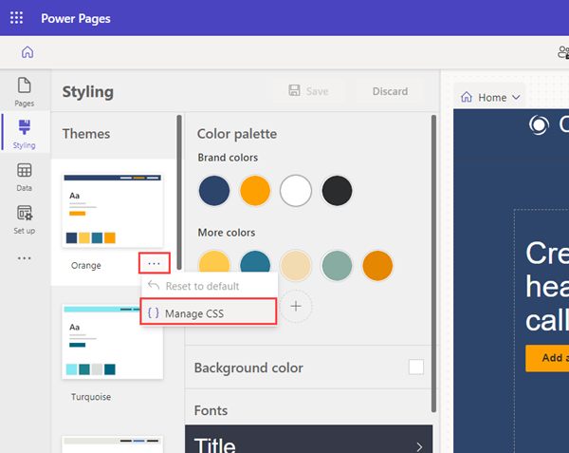

1. In the **Custom CSS** section, select **Upload** and choose your custom CSS file. You can only upload one CSS file at a time, but multiple files can be uploaded. If multiple CSS files update the same attribute, the attributes in the CSS file at the bottom of the list will apply. You can adjust the order of your custom CSS files.
2. You should immediately see the results of the updates on the pages canvas.

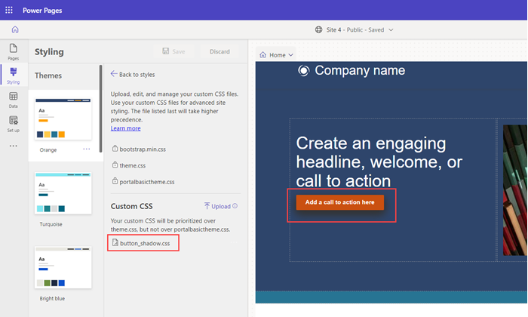

1. You can disable, or move the order of your custom CSS files. The file listed last will take precedence over the others.

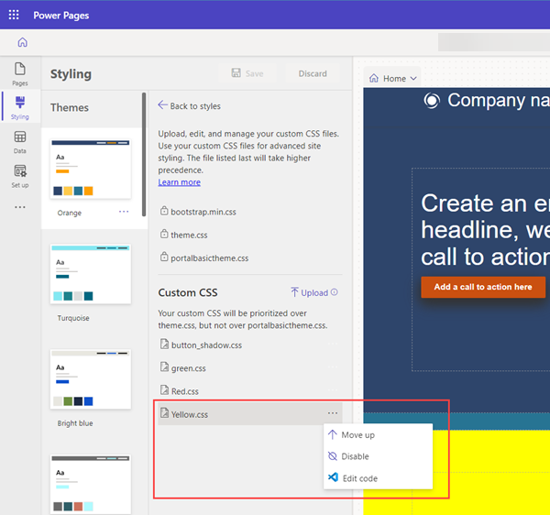

1. You can directly edit a CSS file by selecting the ellipse (**...**) and selecting **Edit code**. This will open the [Visual Code for the Web](https://learn.microsoft.com/en-us/power-pages/configure/visual-studio-code-editor) editor. Select **CTRL-S** to save your changes.

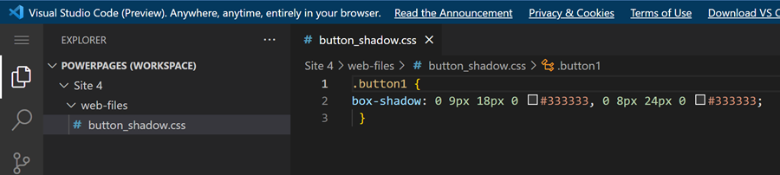

1. Select **Sync** in the design studio to update the CSS and view the changes.
2. Select **Preview** to view the custom theme on your site.